WarkSAR Digital Review

Website Redevelopment and Management

# Document Information

|  |  |
| --- | --- |
| **Version** | 0.2 |
| **Creation Date** | 10/1/21 |
| **Last Review Date** | 26/1/21 |
| **Authors** | Ian Malins – Project Manager  Karl Farrar – Product Owner  Stephen Clarke - Developer |
| **Status** | Draft |
| **Audience** | Warksar Internal  Code Institute for assessment purposes |

# Contents

Document Information 1

Contents 1

Digital Services 1

D4H 1

Social Media 1

Google Drive 1

Website 1

Strategy 1

Appendices 1

# Digital Services

Warwickshire Search and Rescue deploys a number of digital services that support all areas of activity. These include, but are not limited to, communications, training, fund raising, finance and team management.

## Website

The website will be planned and maintained in accordance with five stages of website planning; Strategy, Scope, Structure, Skeleton and Surface.

### Strategy

The main aim of the website is to fulfil the following:

**Inform** – to inform the community about what we do and how we do it. E.g remit, annual report etc

**Communicate** – to provide contact points so that the community in general can get in touch with us and get responses to specific enquiries. E.g. contact emails, social media links etc

**Engage** – provide details on how the community can get involved, provide support and what we can do for them. E.g. joining, support activities such as dog training, donations, recruitment events, fund-raising activities.

### Scope

Maintaining a website is an ongoing task, if well designed that task may be light in total hours. From time to time more major reviews and updates may be required.

Ongoing maintenance would include areas such as events, annual reports, a photo gallery and maybe a video gallery.

Reviews might lead to one or more development sprints. Minor reviews might be annual or in response to operational changes. Major reviews might be on a 3 to 5 year cycle.

For the ongoing maintenance an information policy should be agreed as to what information, photos and videos it is appropriate to publish.

Development sprints would be recorded as an appendix to this document.

### Structure

#### Current Structure

|  |
| --- |
| Persistent Header includes Social Media and Search Tool |
| Top Level Navigation |
|  |
|  |
| Persistent Footer |

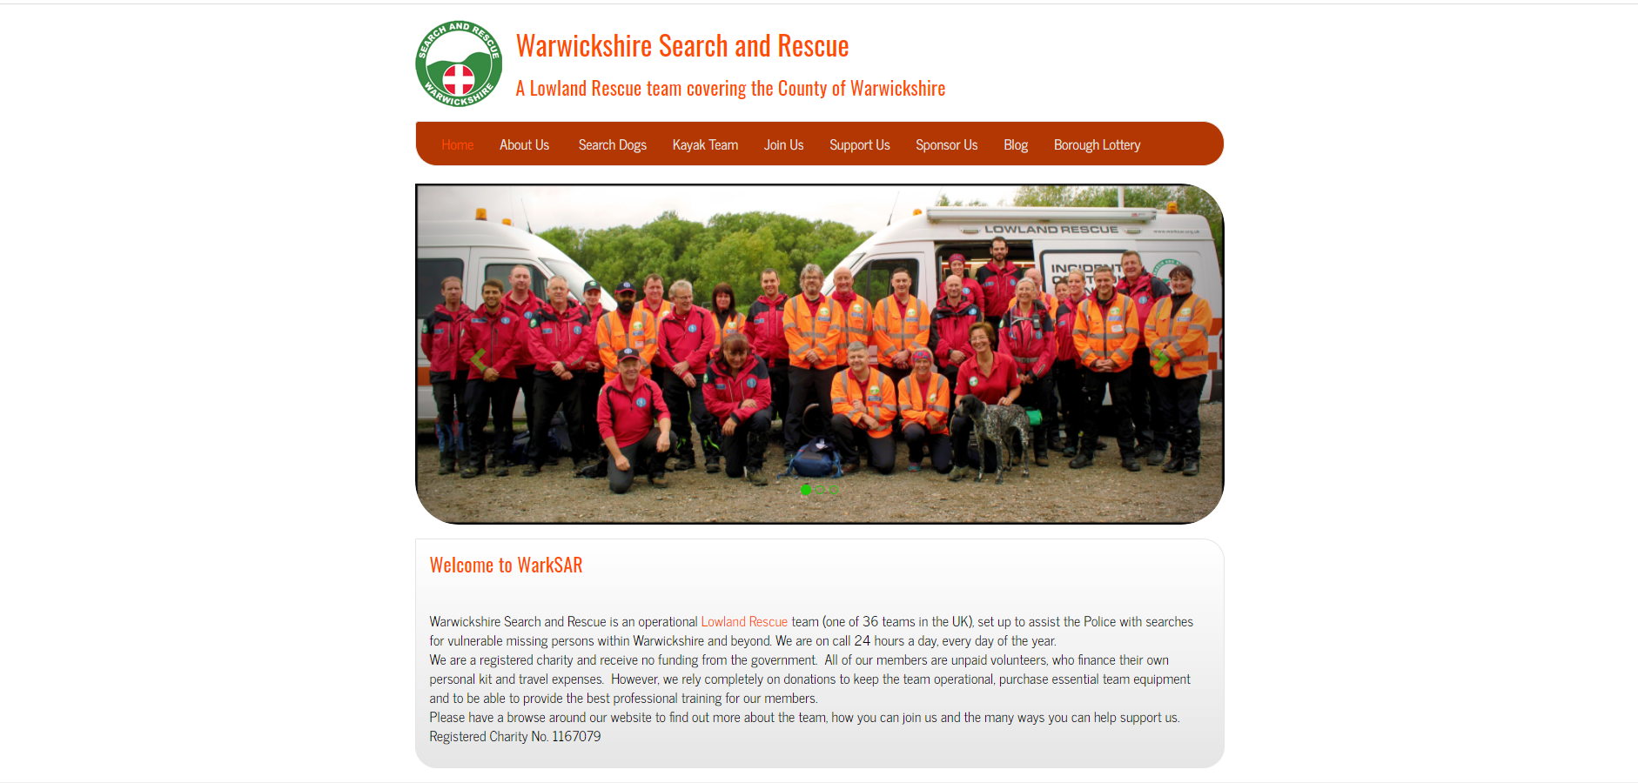

#### Proposed Structure

|  |
| --- |
| Persistent Header includes Social Media and Search Tool |
| Top Level Navigation |
|  |
|  |
| Persistent Footer |

### Skeleton

|  |  |  |
| --- | --- | --- |
| Home |  | Calls To Action |
| About | What We Do |  |
| Our History |  |
|  |  |
| Search Team |  |  |
| Events |  | Chronologically arranged set of short articles on events in which Warksar is involved |
| Get Involved |  |  |
| Gallery |  | Photo Gallery  Video Gallery |
| Contact |  |  |
| Search |  |  |

### Surface

# Glossary

|  |  |
| --- | --- |
| Warksar | Commonly used abbreviation for Warwickshire Search and Rescue |
| Lowland Search and Rescue |  |
| D4H |  |
| G Drive |  |
|  |  |
|  |  |
|  |  |
|  |  |

# Appendices

## Appendix I - Development Sprints

### Sprint 1 – Modernisation

Update to a more contemporary and mobile friendly look and feel, using the same core information and functionality. Consider if any functional areas are no longer required.

### Sprint 2 – Rapid Review

Review all content for accuracy and currency. Make minor modifications or remove old or inaccurate content.

### Sprint 3 – Media Review

Review and update pictures, videos etc. Consider an ongoing strategy to maintain media.

### Sprint 4 – Content Review

Get lead members of the team to review the wording across the whole site

### Sprint 5 – Set Strategic Priorities

Set strategic priorities for future development, and create an outline plan.

## Appendix II – Additional Considerations

We want to review what we can possibly do to in no particular order:-

* Increase views on the website
* Herbert protocol
* Missing person dementia kits
* Increase social media engagement with the public
* Create a calendar of social media opportunities like mental health awareness day
* Link in with Lowland Rescue information
* Increase fundraising opportunities
* Maintain SEO top of the list
* Increase functionality for members to use?
* Review all Lowland Rescue websites to identify opportunities that we don't currently use.
* Review current restrictions on how much information we share about live searches (other teams seem to share more information than we do?)
* Increase usage by members of the public of easy fundraising, virgin giving and anything else that brings in donations.
* Embed amazon wish lists?
* Maintain Lowland Rescue branding guidelines
* Review of website hosting (can be slow to load at times)
* Review of website security and software (work out what wordpress applications are being used, how secure they are, and whether there are better alternatives)
* Add in a "Content Policy " so that everyone knows what we need so that  we can schedule website/social media posts to go live at peak times with good content, rather than the current system of just being sent a low quality photo, days after the event, with no other information.
* Expand the media library to include more photos and videos, and also create content for special events/awareness campaigns/signage.
* Review of photo policy (needs more flexibility than current policy)
* Look at possibility of creating a quarterly/6 monthly newsletter to email to donors so that they can see how their donations are being put to use.
* Look into the possibility of creating some sort of budget for software applications like hootsuite and also advertising opportunities.
* Encourage better engagement from team members for sharing content and spreading positive information.